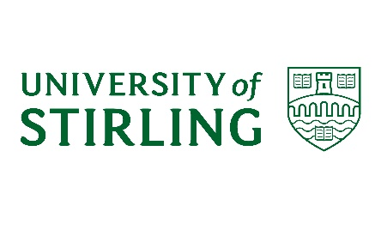

**Find your Future**

The University of Stirling and University of Stirling Students’ Union would like to invite you to ‘find your future’ on 28 August 2017.

You might already have a 10-year plan…or have no idea what you will do tomorrow. Decisions you make now – like what subjects you study at school – can shape your future options and we want to make sure you have all the information you need. You’ll also get the chance to meet students and teachers from the University who can answer any questions you might have.

The event will help you understand the options open to you for when you leave school.

* Are you thinking about college or university?
* Are you already thinking about what subjects you might study? Do you know what you need to do to get in?
* What is it like to be a nurse, a social worker, a mathematician? What jobs are open to you if you study history, biology or criminology?

The event will be led by students from the University of Stirling – they know exactly what it takes, how it feels and what to avoid! It will be fun and interactive and we hope to get out to explore our campus with you. Can you ‘find your future’ amongst our trees, fields and lochs?

We also want to hear from you. We are trying to find out why more boys study computing, maths and sport at university than girls do, and why more girls study nursing, social work and primary teaching. You can help us:

* Who helps you decide what you might do when you leave school?
* Where do you find information on choices for studying?
* Do you understand what it’s like to study at college or university?
* Are there barriers to studying at college or university? How could we get rid of them?

The event will be held on University of Stirling campus on 28 August from 10am-2pm. Lunch will be provided.